PHOTORESISTOR

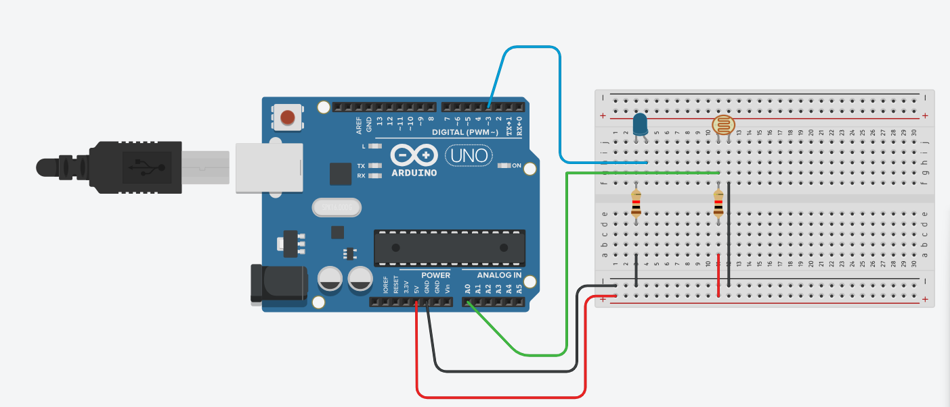
#define pinLed 3
#define pinFoto A0
void setup() {
pinMode(pinLed, OUTPUT);
pinMode(pinFoto, INPUT);
}
void loop() {
analogWrite(pinLed,(analogRead(pinFoto)/4));
delay( 100 );
}

